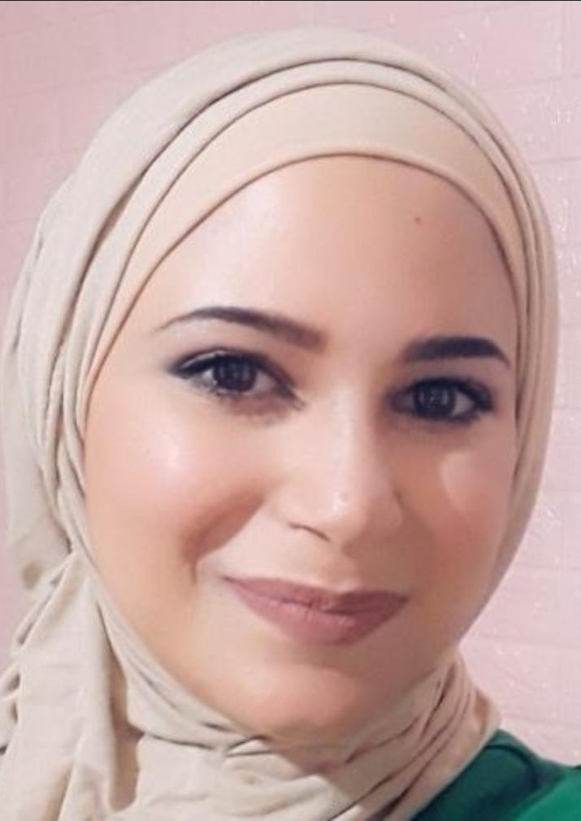 Rawan Galal Issa Alsheebat
Development officer and more ……
Iam a graduate student of Alquds University. I’m studying special education. I intend to apply for this position , because of two reason first , I fell that your vision matches my interesting that supply protection and support for violence victims , and eliminate every form of violence against woman and kids , and providing social guidance to avoid any likely violence . The second reason is related to the offered qualification that attached in the ad , like I write essays which learnt me how convince the reader of my thoughts and ideas , so I think that’s very important for “proposal writing “ , and building a relationship with donor ; in addition , I had online courses about Microsoft word so I have an experience of its usage . In the nine months ago, I got marketing position as a freelance job in some new set ups and min-local companies, which was very helpful to me by skilling me how promotion should be go . I have ultimate goals to do all the best for this position, and please contact me to find out more my skills could bust for your organization.
Best Regards
Phone number : 0592825358
Email address : rawan.staff2000@gmail.com
Telphone number : 2772939
Facebook link : https://www.facebook.com/
Rawan sheebat , Bethlehem – beitsahour .

